EXERCISE: 10

DATE: 23.11.2020

AIM:

To write a Python function that accepts a string and calculate the number of upper-case letters and lower-case letters.

PROGRAM:

def string(s):

d={"UPPER_CASE":0,"LOWER_CASE":0}

for c in s:

if c.isupper():

d["UPPER_CASE"]+=1

elif c.islower():

d["LOWER_CASE"]+=1

else:

pass

print("No. of Upper case characters: ",d["UPPER_CASE"])

print("No. of Lower case characters: ",d["LOWER_CASE"])

s=input()

string(s)

LINK:

[http://103.53.53.18/mod/vpl/forms/edit.php?id=325&userid=1730](http://103.53.53.18/mod/vpl/forms/edit.php?id=325&userid=1730#vpl_file0)

OUTPUT:

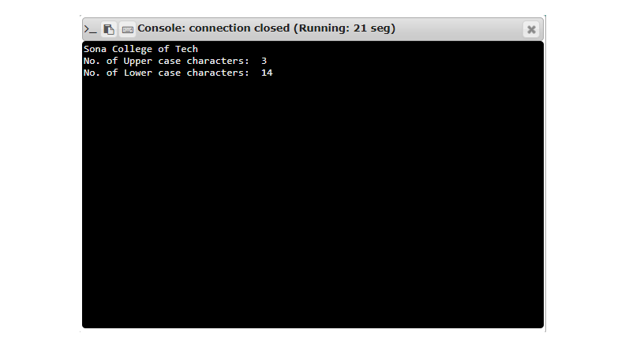

RESULT:

The output of the program is verified successfully